Game Design Document

Fill up the Following document

1. Write the title of your project.

Potions Galore

1. What is the goal of the game?

Collect all the ingredients for Merlin’s potion

1. Write a brief story of your game?

You are Merlin’s Apprentice and Merlin needs your help

to collect all the ingredients for his portion.

Use left and right arrow keys to move.

1. Which are the playing characters of this game?

* Playing characters are the ones which respond to the user based on the input from the user
* Cars, monkeys, dinos, wizards etc, are the playing characters in the game.

|  |  |  |
| --- | --- | --- |
| Number | Character Name | What can this character do? |
| 1 | Merlin’s Apprentice | He can collect all the ingredients. |

1. Which are the Non Playing Characters of this game?

* Non Playing characters are the ones which don't have an action or a behaviour when the user interacts with the game.
* Hurdles, stones, bananas, coins, etc are non playing characters in the game.

|  |  |  |
| --- | --- | --- |
| Number | Character Name | What can this character do? |
| 1 | The ingredients for the potions | Can help Merlin make potion. |
| 2 | Poison | Makes the potion undrinkable and you have to start the game again |

Draw your imagination of this game. What does this game look like?

* Draw the game either on your computer or on paper,
* Add images of scenes of the game to show each of the playing and non-playing characters at least once.

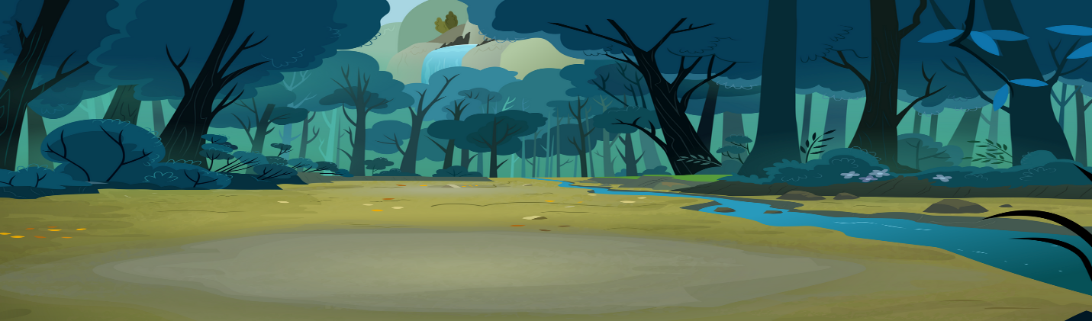

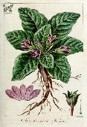 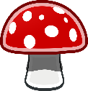

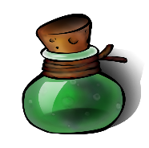

[This Photo](http://turtlegirlman.deviantart.com/art/Green-Potion-83713891) by Unknown Author is licensed under [CC BY-NC](https://creativecommons.org/licenses/by-nc/3.0/)

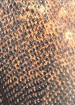

[This Photo](http://commons.wikimedia.org/wiki/File:Komodo_dragon_skin.jpg) by Unknown Author is licensed under [CC BY-SA](https://creativecommons.org/licenses/by-sa/3.0/)

How do you plan to make your game engaging?

The ingredients will appear in random places and you have to be careful

Not to collect the poison. The game will get faster as you play.